**Experiment name:**

Diode Rectifier circuits

**Objectives**

We will study different diode rectifier circuits.

**Apparatus**

* 4🇽 p-n junction diode (1N4007)
* Resistor: 1🇽 10kΩ
* Capacitor: 1🇽 0.22µF, 1🇽 10µF
* Signal generator
* Oscilloscope
* Digital Multimeter
* Chords and wires

**Theory:**

A rectifier is an electrical component that converts an alternating current (AC) signal to a direct current (DC) signal. A diode allows the current to flow in the forward bias while in the reverse bias, it acts as an open circuit. So, when an alternating voltage (AC signal) is applied across a diode, it only allows the half of the cycle to pass in the forward-biased condition. The other half of the cycle is blocked. As a result, the output across the load will be a DC signal.

There are two types of diode rectifiers-

1. Half-wave rectifier
2. Full-wave rectifier

**1. Half-wave rectifier:** A half-wave rectifier is usually built using a single diode and it allows only one half (either positive or negative) of the AC waveform to pass through, while the other half is clipped off. As a result, the average DC voltage is low. Moreover, due to the presence of ripple, the output voltage is not a smooth one.

**2. Full-wave rectifier:** A full-wave rectifier utilizes both the half cycle of the AC input. Two circuits used as full-wave rectifier are shown below –

1. **Full-wave rectifier using center-tapped transformer:** Two diodes are connected to the ends of the transformer and the load is between the diode and center tap. A full-wave rectifier using a center-tapped transformer circuit has several advantages over full-wave rectifiers, including less wastage of power, a significant increase in average DC output, and a smoother waveform. However, there are also disadvantages, such as it requires more space and becomes bulky due to the transformer, and it is not cost effective.
2. **Full-wave bridge rectifier:** A bridge rectifier overcomes all the disadvantages of a rectifier using a center-tapped transformer. Here four diodes are connected as a bridge connection. This rectifier however cannot produce a smooth DC voltage. It produces some ripple in the output. This ripple can be reduced by using a filter capacitor across the load.

**Circuit Diagram:**

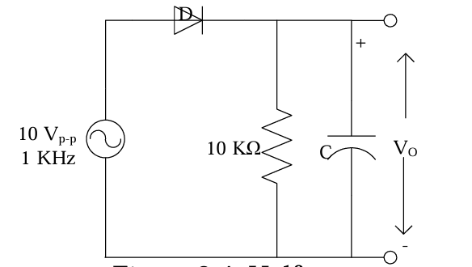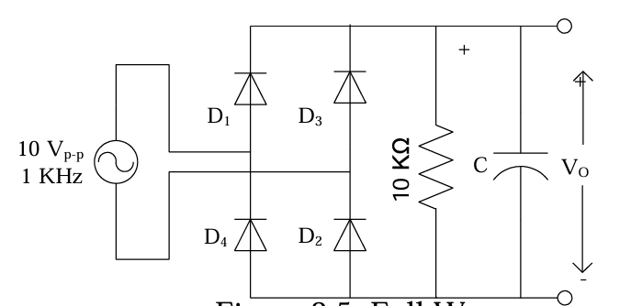

**Half wave Full wave**

**Experimental Procedure:**

1. First, we connect the circuit to the breadboard, as shown in the half-wave figure, without any capacitor.

2. We apply 1 KHz 10V (p-p) sinusoidal input signal from signal generator.

3. Then, we connect channel 1 of an oscilloscope to the input side and channel 2 of the oscilloscope to the output side. We observe the wave shapes and p-p values inputs and outputs and draw them on the graph paper with proper p-p values.

4. We connect the 0.22µF capacitor and repeat step 3. [Decreasing the Volts/DIV for proper wave shape]

5. Now, keeping the capacitor fixed at 0.22 µF, we observe the change in output wave shape by 1st varying the frequency lower than 1 kHz and then higher than 1 kHz.

6. Then, we connect the 10µF capacitor and repeat steps 3 and 5. [Decreasing the Volts/DIV for proper wave shape]

7. Repeat steps 1-6 for the Full wave figure.

**Experimental Data Table:**

**Results:**

In this experiment, we aimed to make the AC signal into a DC signal by half and full wave rectifier. We used a capacitor for stable output voltage during the half and full-wave rectifier experiment.

**i) Observations without capacitor:** In the half-wave rectification, when we built the circuit without a capacitor, the output was found only during the positive half cycle of the input. When the input was negative, there were ripples in the graph in the oscilloscope. The average DC voltage is low, the load receives approximately half of the input power because of the ripples, and the output voltage is not smooth.

In the full-wave rectification, the output voltage is also found in the negative half cycle of the input, increasing the average DC voltage. Although the average DC voltage is increased, there are still ripples in the graph, which can be reduced using capacitors.

**ii) Observations with capacitor:** When we used a **0.22µF** capacitor across the load in both the half-wave and full-wave rectifier circuits, the ripple effects are seen to be decreased. It means that the capacitor helps the circuit to keep the output voltage steady for a longer period of time.

When we used a **10µF** capacitor across the load in both the half-wave and full-wave rectifier circuits, the output voltage was found to be a straight line in the oscilloscope, which means that the rectifier circuit was able to keep the output voltage steady for more than when we used 0.22µF capacitor across the load.

**Questions and Answers:**

**1. For Fig 2.4 and Fig 2.5, draw the input-output wave-shape without capacitor, with 0.22µF capacitor and 10µF capacitor.**

**Ans:**

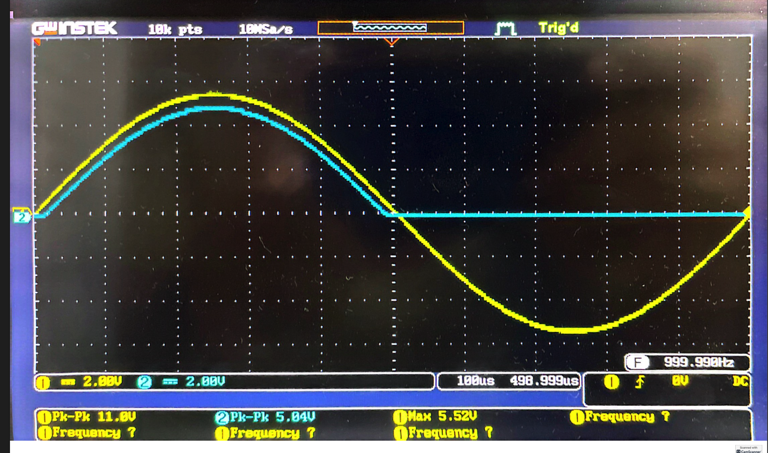 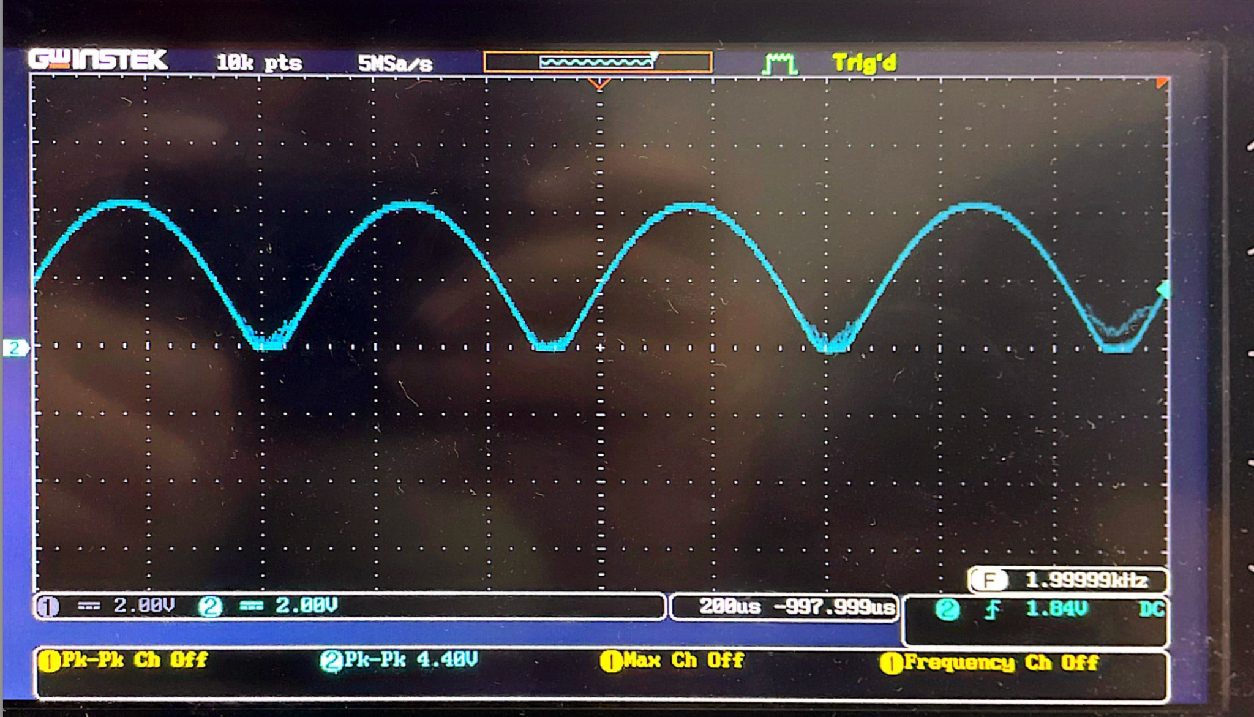

**Input-output without capacitor (fig 2.4) Input-output without capacitor (fig 2.5)**

**(Half wave rectifier) (Full wave rectifier)**

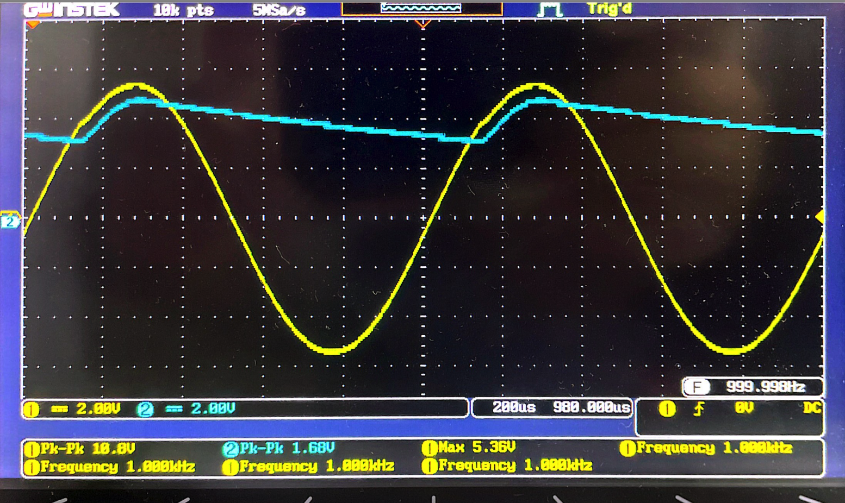 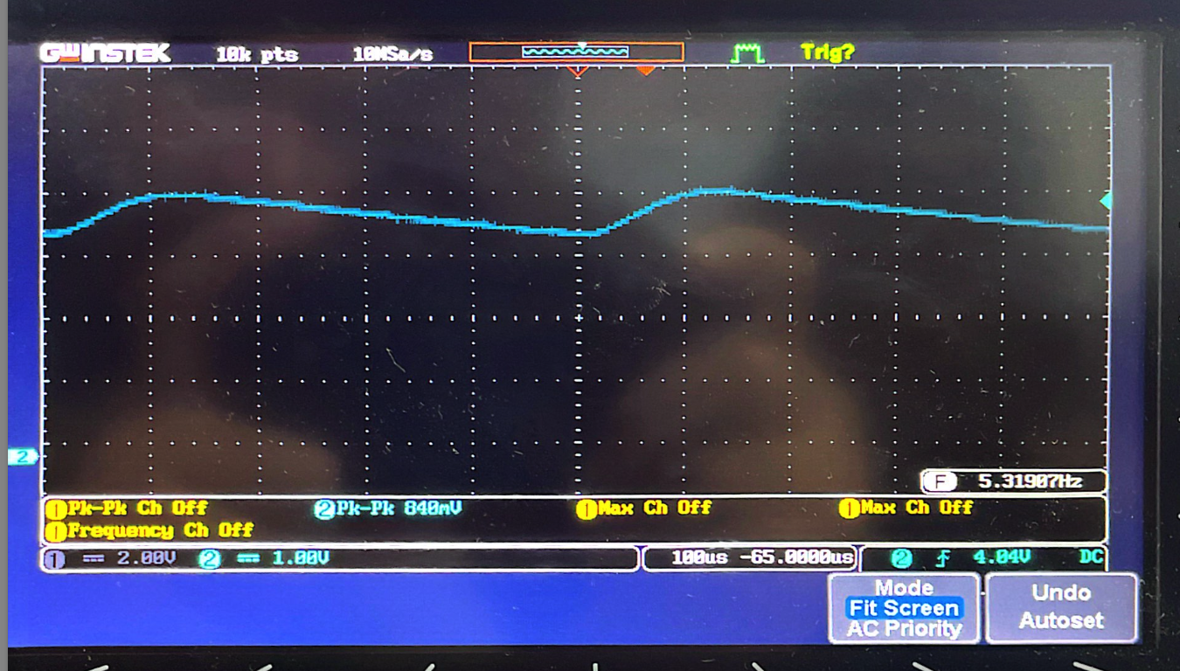

**Input-output with 0.22uF (fig 2.4) Input-output with 0.22uF (fig 2.5)**

**(Half wave rectifier) (Full wave rectifier)**

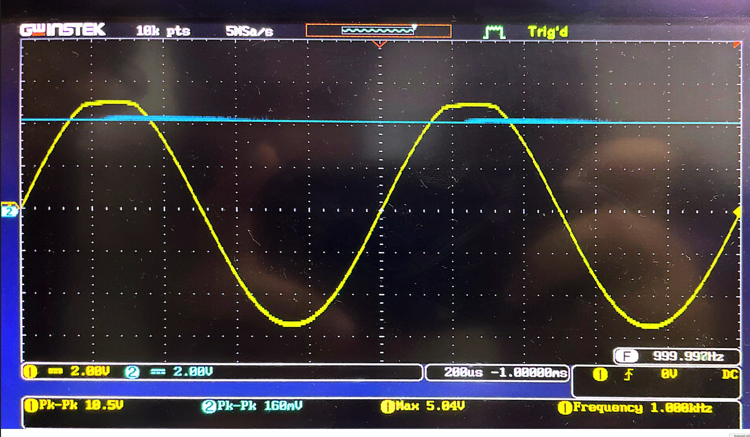 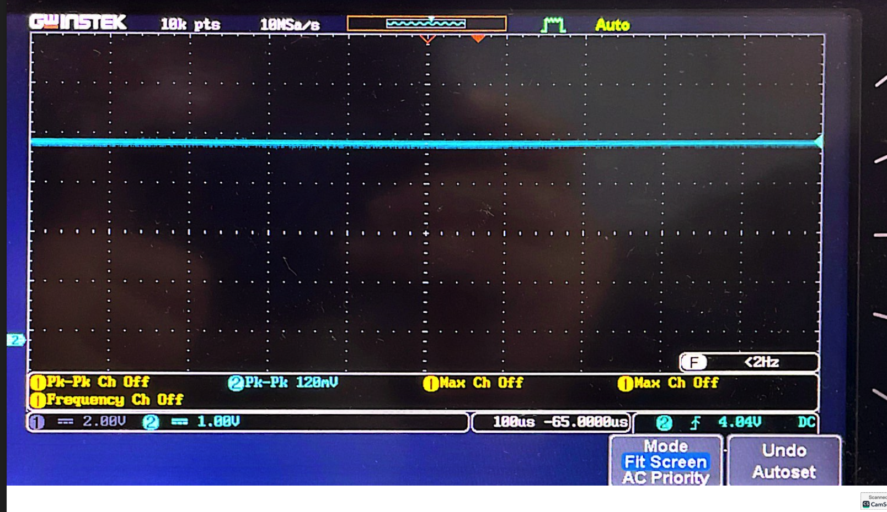

**Input-output with 10uF (fig 2.4) Input-output with 10uF (fig 2.5)**

**(Half wave rectifier) (Full wave rectifier)**

**2. Compare the change in the wave-shape and peak-to-peak values for no capacitor at the output to 0.22 µF to 10 µF.**

**Ans:**

**Without a capacitor:**

- The waveform of the half-wave rectifier was irregular.

- For the full-wave rectifier, the waveform was more consistent, but the output voltage was not stable. The peak-to-peak values were 5.04 Vpk-pk for the half-wave rectifier and 4.40 Vpk-pk for the full-wave rectifier.

**With a 0.22 μF capacitor:**

- The waveform for both rectifiers became less variable, approaching a more constant or DC-like signal.

- For the full-wave rectifier, the output was nearly constant. The peak-to-peak values were reduced to 1.68 Vpk-pk for the half-wave rectifier and 840 mVpk-pk for the full-wave rectifier.

**With a 10 μF capacitor:**

- The waveforms for both rectifiers were nearly constant, closely resembling a DC signal.

- The peak-to-peak values were significantly reduced to 160 mVpk-pk for the half-wave rectifier and 120 mVpk-pk for the full-wave rectifier.

**3. Explain the effect on the output signal for changing the frequency of the input signal.**

**Ans:** Changing the frequency of the input signal will have a noticeable effect on the output signal. As the frequency of the input signal increases, the output signal will experience more frequent ripples. This is because the charging and discharging cycles of the capacitor occur more rapidly at higher frequencies, leading to more frequent fluctuations in the output waveform. Consequently, the overall ripple frequency increases, though the amplitude of these ripples may decrease depending on the capacitance and the rectifier type.

**4. Between half wave and full wave which circuit produces smoother output? Briefly explain in context with your data collection.**

**Ans:** Between the half-wave and full-wave rectifiers,the full-wave rectifier produces a smoother output. Based on our experimental data and graphs, the half-wave rectifier shows more ripple in the output, while the full-wave rectifier significantly reduces ripple. This is because the full-wave rectifier utilizes both halves of the AC cycle, resulting in a more consistent and stable output. Therefore, the full-wave rectifier provides a much smoother signal compared to the half-wave rectifier.

**Discussion:**

In this experiment, we explored two diode rectifier circuits — half-wave and full-wave rectifiers—and analyzed how adding a capacitor to the circuits affected their performance. We observed that the half-wave rectifier converted only the half cycle of the input signal into a DC signal. The oscilloscope showed ripples in the graph, and the curve was not smooth. Hence, the average DC voltage was low. In contrast, the full-wave rectifier converted both half cycles into a DC signal, which resulted in an increased output voltage. But there were still ripples in the graph.

Adding a capacitor of 0.22 μF made the curve of the half-wave and full-wave rectifier smoother, with much less ripples in the curve. With the larger 10 µF capacitor, the output was nearly constant as the graph appeared to be a straight line, indicating that the circuit was able to produce a more stable DC voltage.

In conclusion, the full-wave rectifier produced a smoother output than the half-wave rectifier due to its ability to convert both the positive and negative halves of the AC signal to a DC signal. Using capacitors improved the stability of the output by reducing ripple effects. For the load resistance connected across the output of the rectifier, the larger capacitor provided closer output to its peak output voltage.

**Simulation:**



